ONLINE SERVICE WEB SITE
design document

Version 0.1

Revision & Approval

DATE | VERSION | DESCRIPTION | AUTHOR (S) | REVIEW

TABLE OF CONTENTS
1. HIGH LEVEL ARCHITECTURE 3
1.1 General Architecture 3
1.2 Modular Design 3
1.2.1 Web Client 4
1.2.2 Presentation Controller 4
1.2.3 Web Request Handler 5
2. USER CASE DIAGRAMS 6
2.1 General functions 6
2.2 Administration 7
3. CLASS DIAGRAMS - (Overall system) 8
5.1 Shopping : (Browse products, Shopping cart, Product search) 9
5.2 Administration 10
6 SEQUENCE DIAGRAMS 11
6.1 Shopping 11
6.2 Product search 11
7 DATABASE 13

HIGH LEVEL ARCHITECTURE

General Architecture
Application architecture will be based on an n-tier system that emphasizes separation of system components to allow for a distributed system that is scalable, portable and extendable. The application tier will include:
- Client Tier: the client-side application runs on client machine’s web browser. It interacts with MVP online shopping system via Internet. Web browser of client machines can be a commercial or open-source browser that is compatible with HTML, XML and supports frame layout.
- Presentation Tier: this layer renders HTML, WML etc. and delivers it to the client tier over HTTP. It may contain Java applets, JavaScript, JSP and normal Java classes. The presentation layer can be built based on Apache’s Struts Framework version, open-source software under the terms of the Apache Software License ( http://jakarta.apache.org/struts ). Apache Struts has proved its capability and usefulness in separation of logic, presentation and content of web pages.
- Business Tier: this tier encapsulates business logic of functional modules mentioned in the SRS.
- Data Tier: The application database is designed for self-configuring, self-optimizing and self-managing capabilities by using the Oracle Database.

Modular Design
Application is decomposed into several components corresponding to the multi-tier architecture and business functionality as shown in the following diagram:

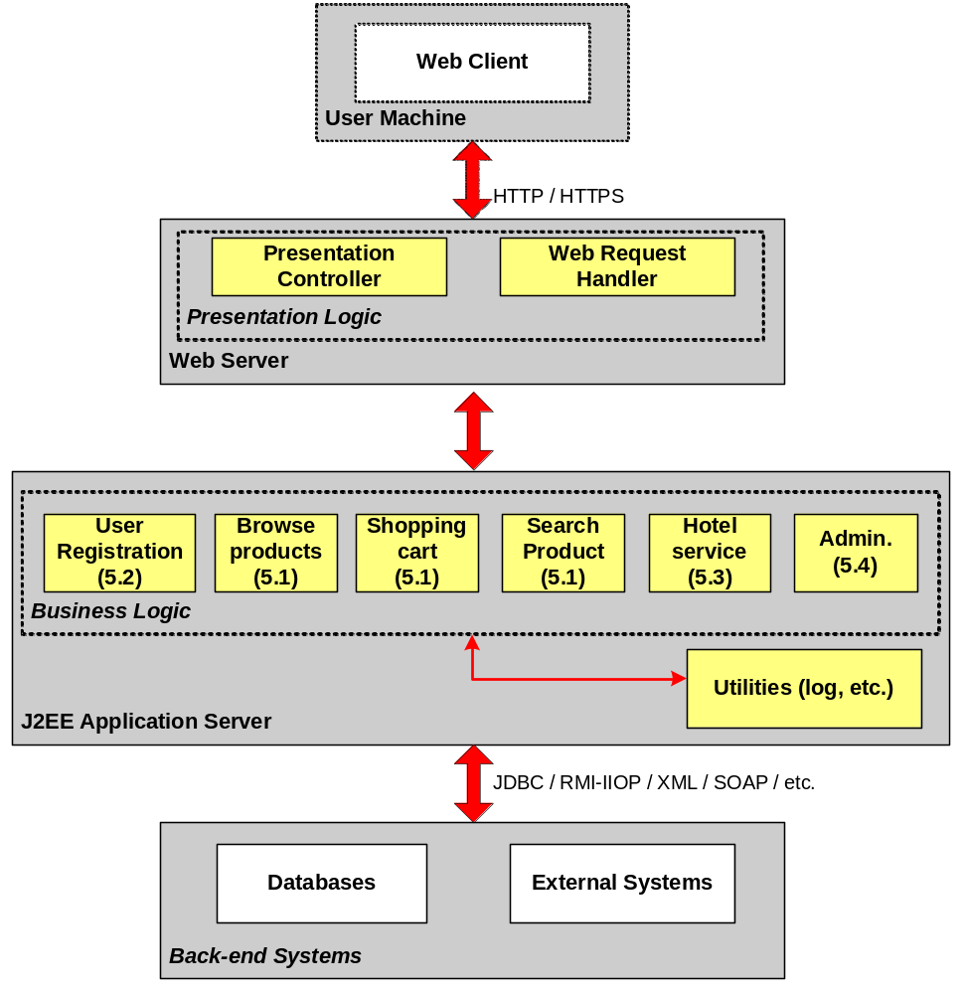 Figure 1 – Modular Architecture

Web Client
Web Client is the client-side application that runs on client machine’s web browser. It interacts with the online shopping system via Internet.
Web browser of client machines can be a commercial or open-source browser which is compatible with HTML, XML and supports frame layout.

Presentation Controller
This component is located on the web server and may contain Java applets, JavaScript (both of them will be loaded and executed on client side at run-time), JSP and normal Java classes that are used for data preparation, calculation (e.g. make statistics of page hit) and validation.

Web Request Handler
This component runs on the web server and helps to separate the layout control of requests from the presentation. It contains request handling functions that connect to stateless EJB beans running on the application server (if any).
Custom JSP Tags (JSP Tag Libraries) will be used to build this component.
These two components, Presentation Controller and Web Request Handler, can be built based on Apache’s Struts Framework, open-source software under the terms of the Apache Software License (http://jakarta.apache.org/struts). Apache Struts has proved its capability and usefulness in separation of logic, presentation and content of web pages.
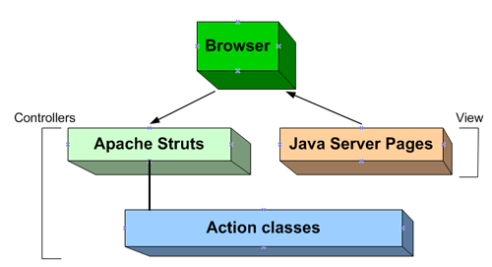
Figure 2 - Using Struts framework in the Presentation Logic

USER CASE DIAGRAMS

General functions

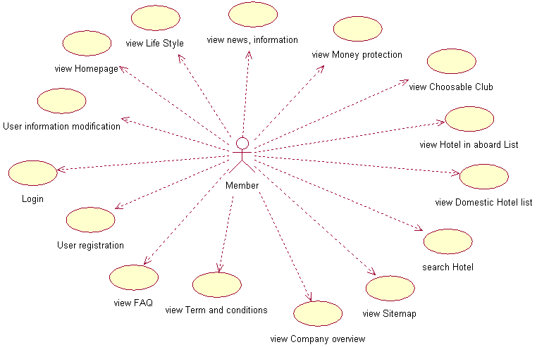

USE CASES | DESCRIPTIONS
Login | Member is required to fill into login form with member’s email address and password to access this website.
User registration | To become member of the website, user has to fill in a registration form. After got an approval from Administrator he/she become a member and can access this website with email and password.
User information modification  (Registered user only) | Registered users (member) can change their account information after login.
View FAQ
View Term and conditions
View company overview
View sitemap
Search hotel
View Domestic hotel list
View Hotel in aboard list
View choosable Club
View money protection
View News, information
View Life Style
View home page

Administration

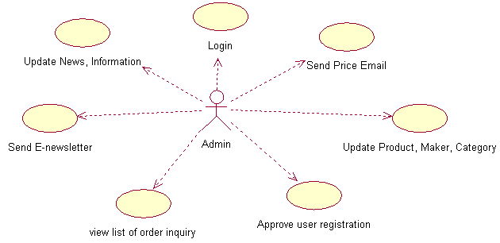

USE CASES | DESCRIPTIONS
Login
Update News, information
Send E-newsletter
View list of Order inquiry
Approve user registration
Update products, Maker, Category
Send price email

CLASS DIAGRAMS - (Overall system)

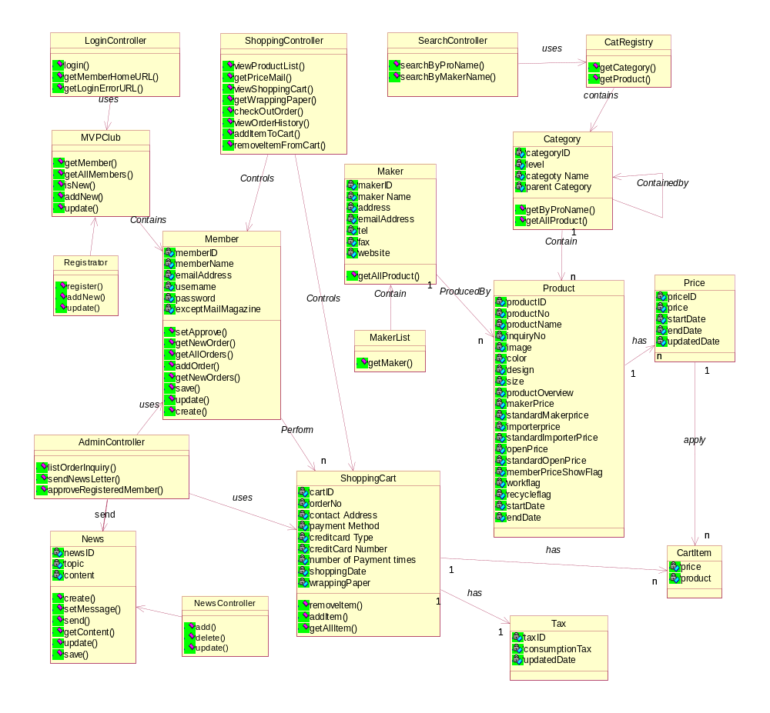

Shopping : (Browse products, Shopping cart, Product search)

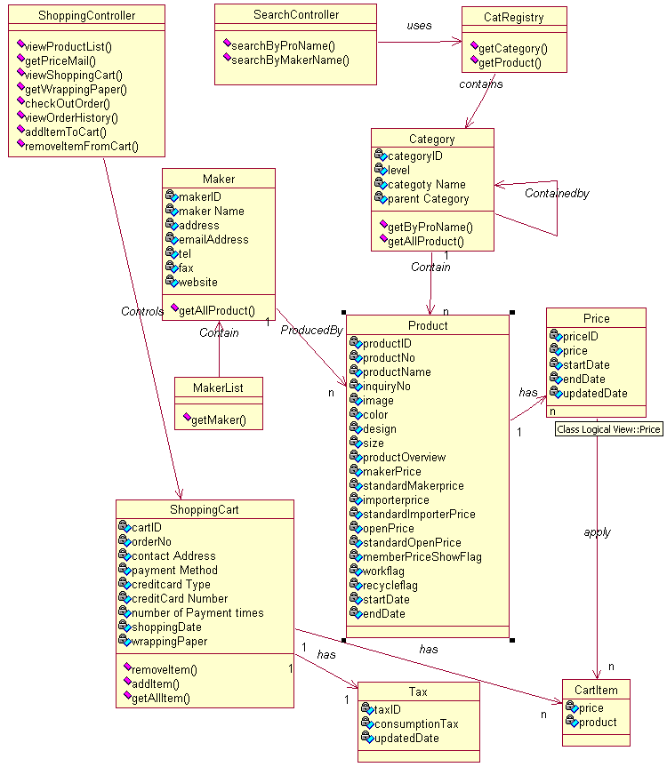

Administration

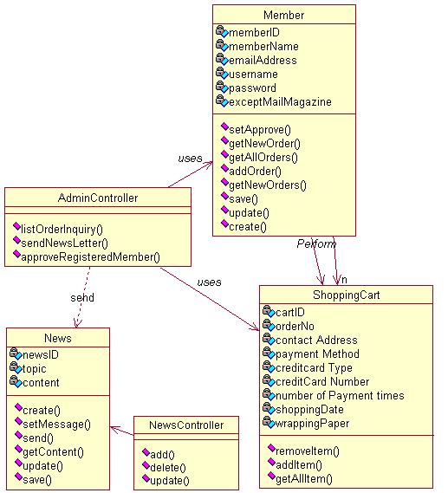

SEQUENCE DIAGRAMS

Shopping

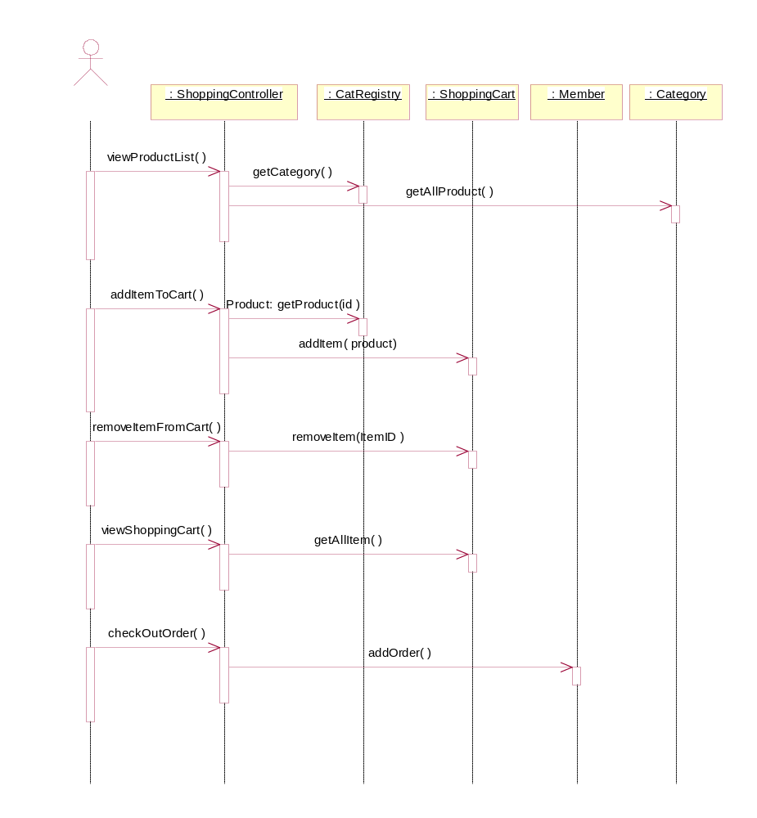

Product search

After login member can click on navigation bar to open search function. This function allow member can search by product name with Product Category and Product maker or by Product maker with Product category…
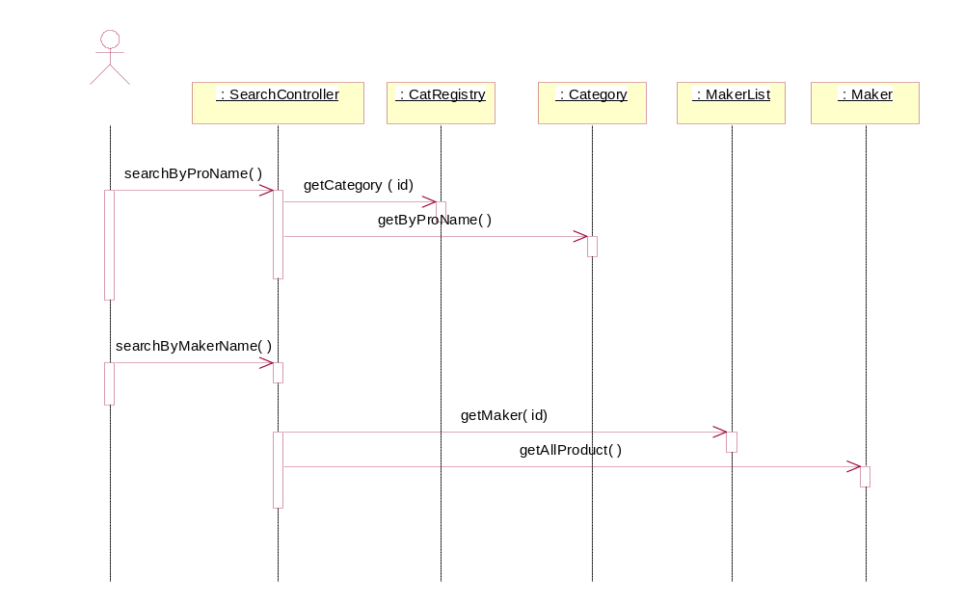

DATABASE
Business Subsystems can communicate with databases by using JDBC.
The details of database structure will be developed as following diagram:
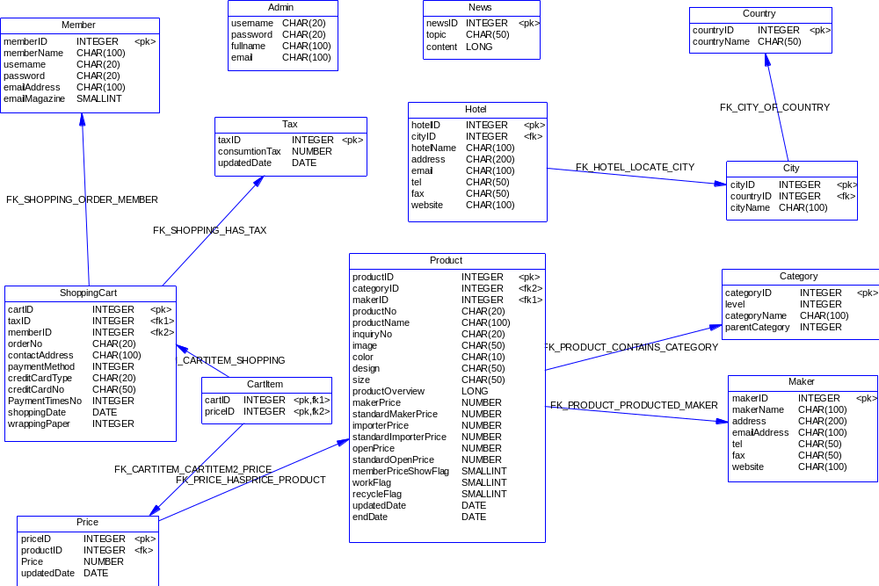

-----------End of file -------------

